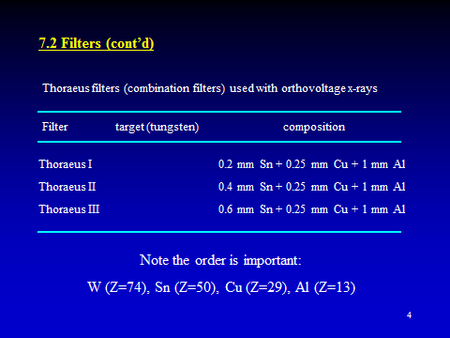
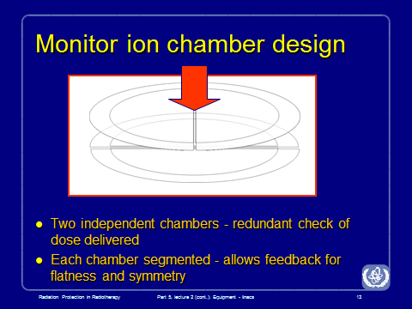

- Electron Cone
An electron cone is fitted to the treatment head, and is available in several preset sizes. This applicator has several collimators which attenuate any lateral scatter. It usually extends to just several centimetres from the surface. The most distal aperture may have an electron cutout fitted. This allows the field to be shaped appropriately, and is located in this position to prevent lateral scatter causing blurring of the beam edge.
- Factors that affect PDD:
- Energy ==> Increases
- Field size ==> Increases
- SSD ==> Increases
- Depth ==>Decreases
By energy at 100 cm SSD, 10x10 field, and depth of 10cm
- Co-60 56%
- 4MV 61%
- 6MV 67%
- 10MV 73%
- 20MV 80%
- 25MV 83%
Photon d_max (cm)
- Co-60 0.5
- 4MV 1.0
- 6MV 1.5
- 10MV 2.5
- 15MV 3.0
- 18V 3.2
- 20MV 3.5
- 25MV 4.0
Probability of interaction:
- Coherent scattering ≈ Z
- Photoelectric absorption ≈ Z³/E³
- Compton scattering ≈ independent of Z, ≈ 1/E, ≈ electrons/gram
- Pair production ≈ Z²

